LIVE TREATS FROM AROUND THE WORLD
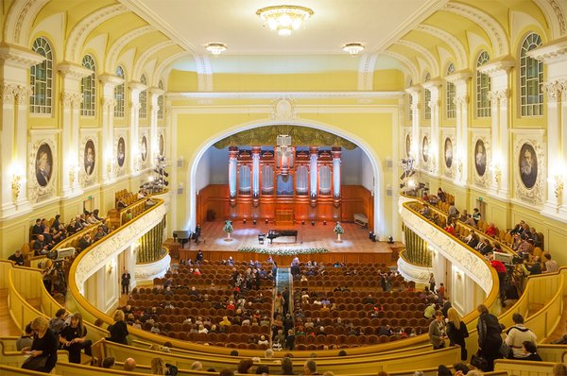
The Great Hall of the Moscow Conservatory is the stunning venue for the 100th anniversary concert of the Moscow Philharmonia. Watch LIVE on Medici TV on January 29th at 4.00pm (GMT)

